Name:
Date:
16.06 Picture Lab Worksheet
Directions: Make note of your responses to the following questions as you work through the activities and exercise in the lesson.

Activity 8 Exercise Results

- Paste the image that is the result of calling the second copy method that adds parameters to allow you to copy just part of the fromPic.
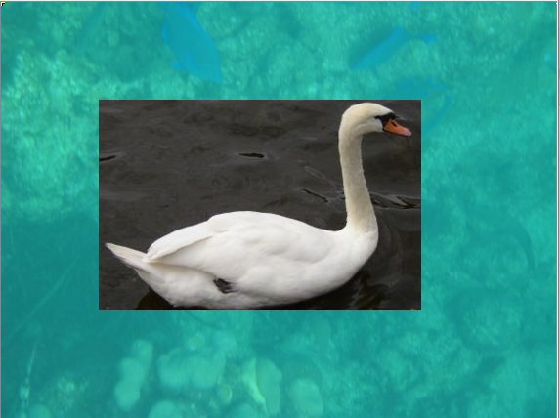
- Paste the image that is the result of calling the myCollage method.
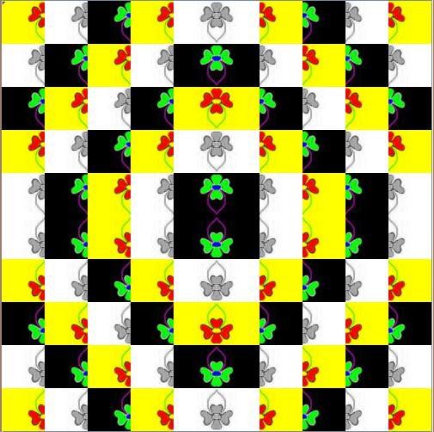
Activity 9 Exercise Results
- Paste the image that is the result of calling the edgeDetection2 method.
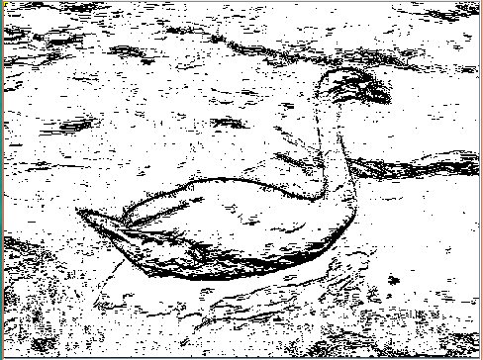
- Think about and propose another algorithm for edge detection.
An algorithm could use a similar process to the one described earlier but combine results from various directions. The algorithm would start by making 4 copies of the pixel array, and then run the original edgeDetection algorithm on the first pixel array (left to right), the new edgeDetection algorithm on the second pixel array (top to bottom), an edgeDetection algorithm checking diagonally from top left to bottom right on the third pixel array, and an edgeDetection algorithm checking diagonally from top right to bottom left on the fourth pixel array.
The top left to bottom right, diagonal edgeDetection algorithm would contain double for loops with i going from 0 to pixels.length - 1 and j going from 0 to pixels[0].length – 1. pixels[i][j] would be compared to pixels[i + 1][j + 1] and if the colors were different enough, the pixel at i, j would be black.
The top right to bottom left, diagonal edgeDetection algorithm would something similar from the opposite direction.
Once the 4 arrays would be modified, the overall argument would combine them by setting the pixel at a particular location to black if any of the pixels in the 4 arrays were black.
The benefit of this algorithm is that it will display edges from many different angles and prevent edges from being missed. It portrays a more complete picture than the current algorithm.

